Uniform for Eagles’ Nest Kindergarten Students

The uniform this year will be the same as the previous years at Eagles' Nest. We highly prefer you purchase the Cherokee brand available at Target for uniformity among the students.

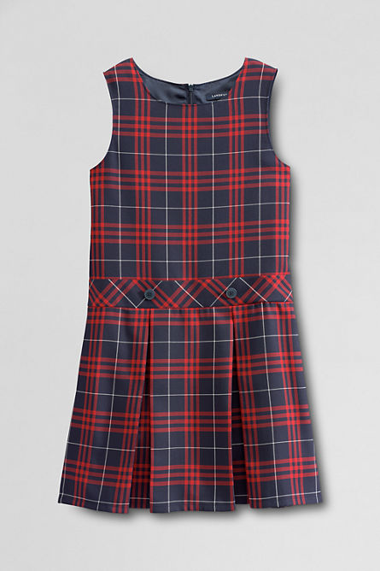
GIRLS
- red short sleeve polo shirt (Target)
- plaid jumper (Lands’ End) http://www.landsend.com/pp/StylePage-65010_BQ.html?CM_MERCH=REC-_-FPPP-_-GGT-_-1-_-65010-_-403640
- black biker shorts under jumper
- black or brown ‘Mary Jane’ shoes for special events and black, navy blue or
brown sneakers or tennis shoes.
- white socks or tights
BOYS
- red short sleeve polo shirt (Target)
- navy blue uniform shorts and/or flat front pants
- black or brown dress shoes (for special events) and black, navy blue or
brown sneakers or tennis shoes.
- black or brown belt
Layering with long sleeve undershirts is permissible on colder days, as well as, using cardigans or pull-over sweaters. Please stick to the uniform colors of red, white, or navy blue and all additional clothing should be free of decorations and/or designs.

Hair accessories for girls, please maintain the color of the uniform,

